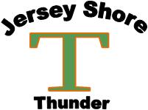

Age Champion Runner-Up
10U Middletown Allstars Pittsburgh Dawgs
11U (50/70) Jersey Shore Thunder Piermont Yankees
12U Manalapan Fusion Brick Bulldogs
13U Jersey City Cobras Jersey Shore Thunder
14U Jersey Shore Raiders Pittsburgh Dawgs Gold
15/16U Pittsburgh Diamond Dawgs Middletown Warriors
17/18U Langan Baseball Pittsburgh Dawgs

