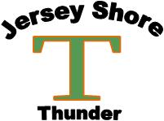

Age Champion Runner-Up
9U Massapequa Cyclone Lincroft Knights
10U North Wall Knights Ocean Stingrays
11U (46/60) North Wall Knights North Howell Storm
11U (50/70) Lincroft Knights Millstone Mariners
12U Manalapan Fusion Westchester Renegades
13U Jersey Shore Thunder Middletown Vipers
14U Wall Knights South Brunswick Vikings
15/16U Middletown Crush Tinton Falls Frozen Ropes

